**LAB – 1**

Name: Gandevia Keval Dharmeshbhai

Sem: VII

Roll No: CE046

Subject: Big Data and Analytics

**Aim:** Recording types of data and various file formats. Identifying data sources. Handling traditionally to start with a small scale.

**Q. 1: Given the spreadsheet file convert it into a csv.**

* There are many ways to convert the spreadsheet file into csv.

1. **Save As spreadsheet file with .csv extension.**

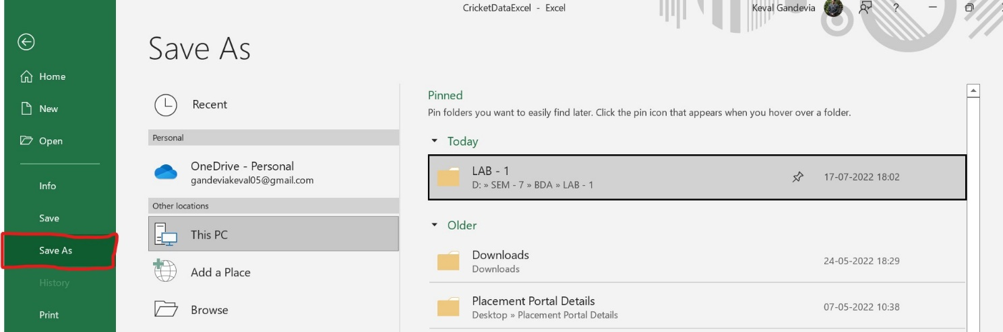

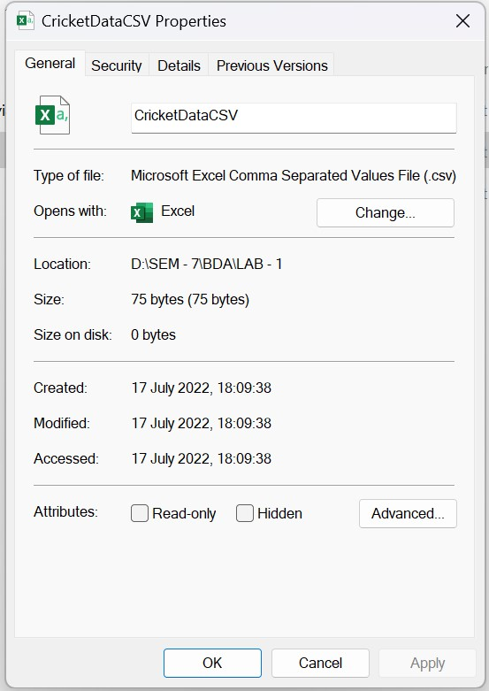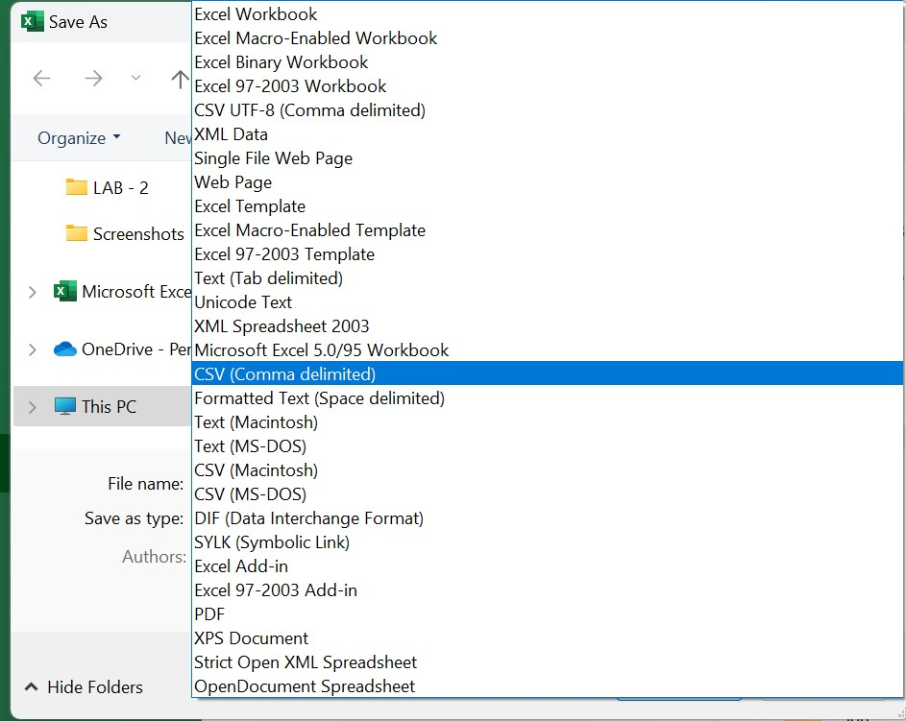

1. 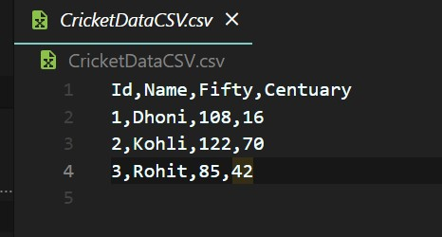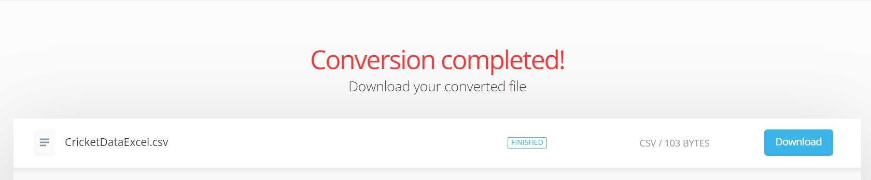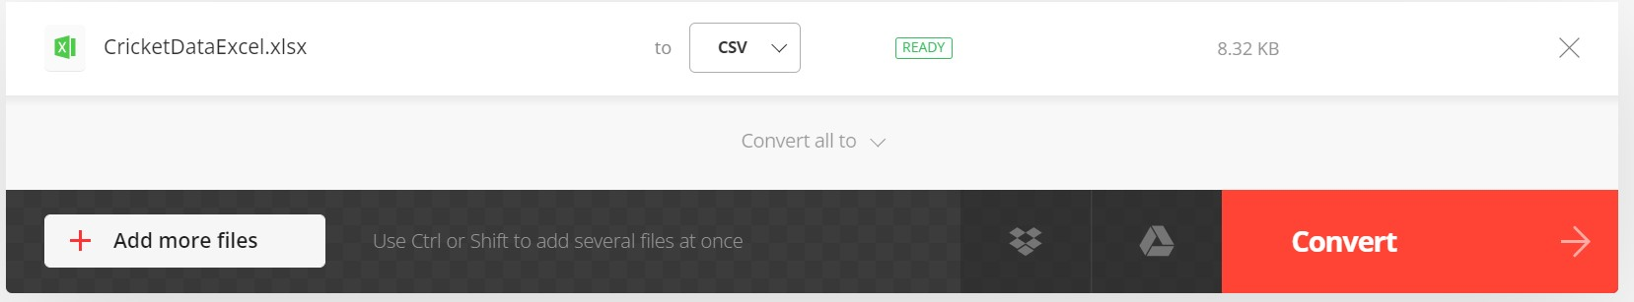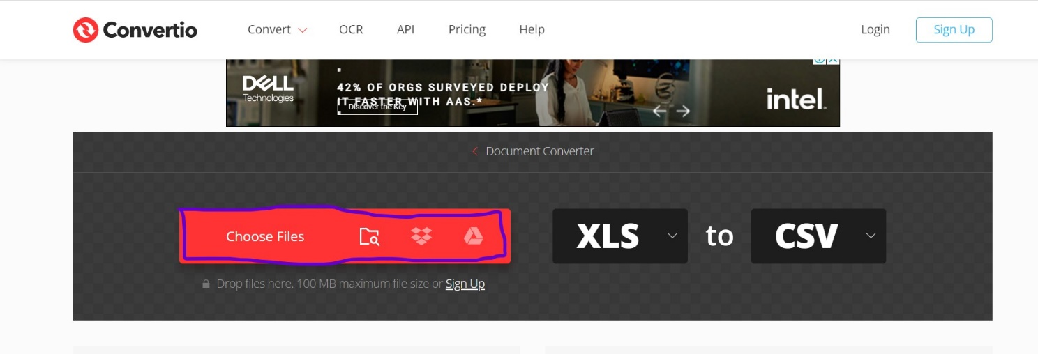**Use online converter.**

**Q. 2: Import csv into MySQL database table.**

* 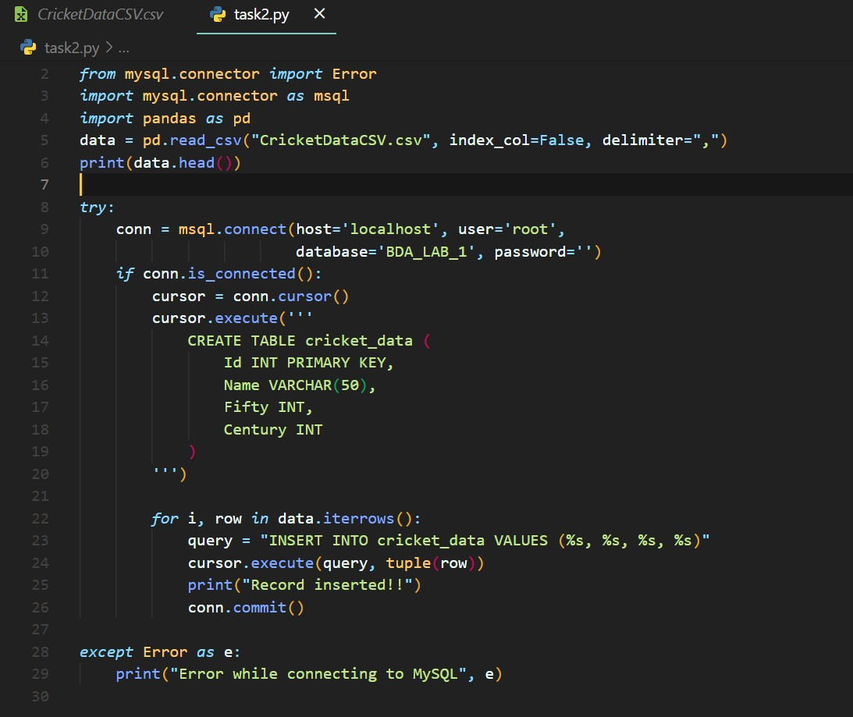**Code:**
* 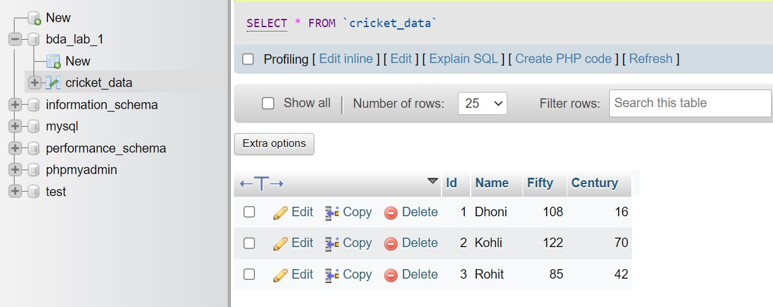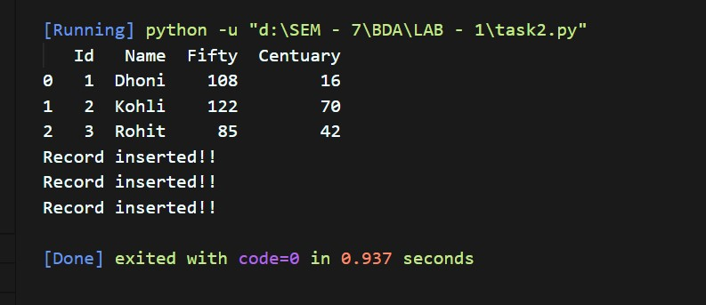**Output:**

**Q. 3: Write a computer program to read records from database and generate data file.**

1. **XML**
   * **Code:**

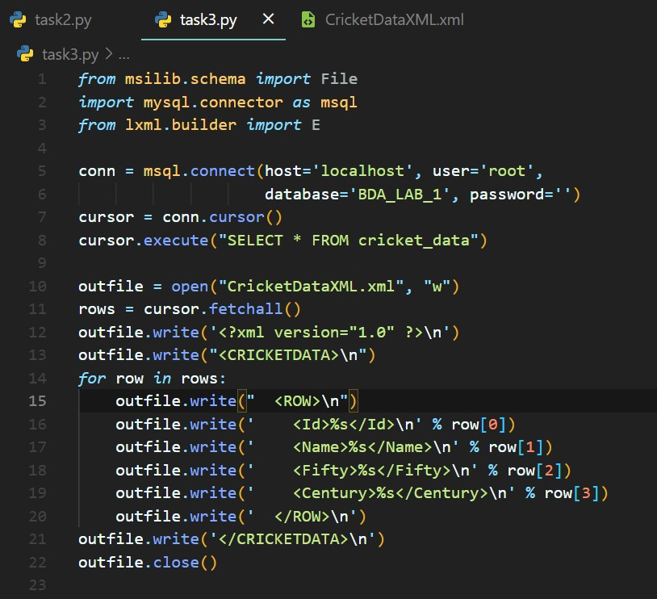

* + **Output:**

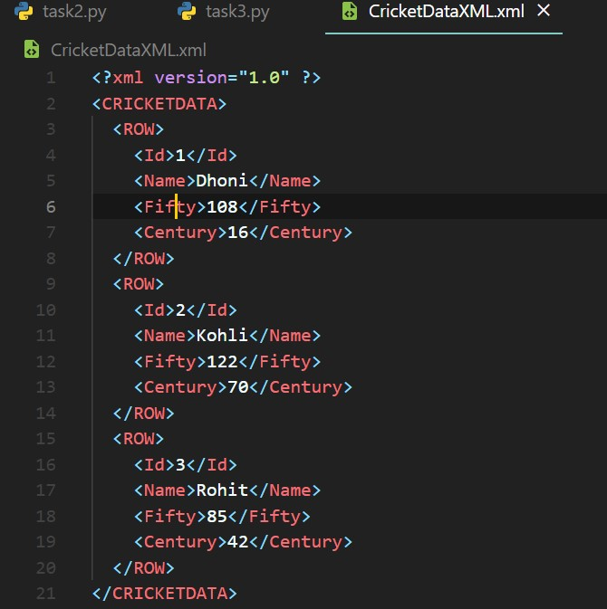

1. **JSON**
   * **Code:**

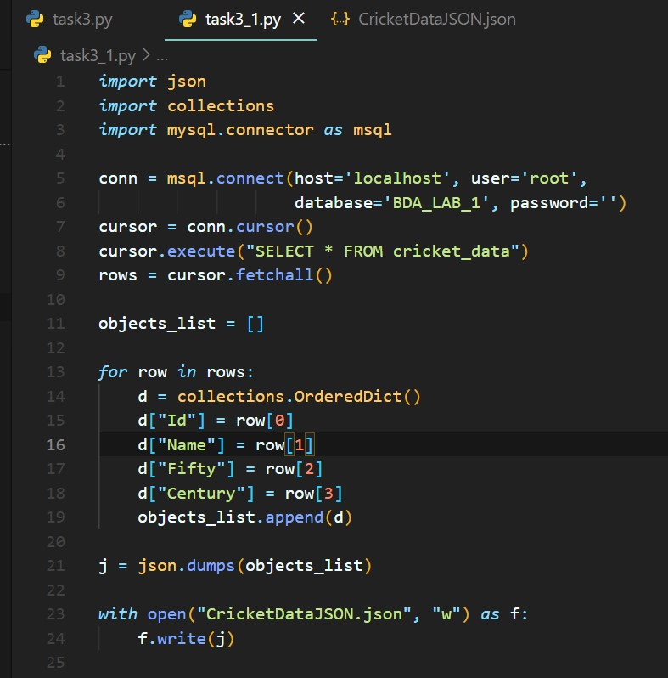

* + **Output:**

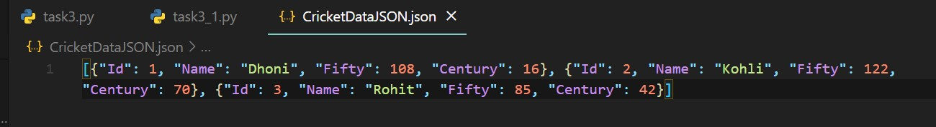

**Q. 4: Import XML/JSON file into another database/table.**

* 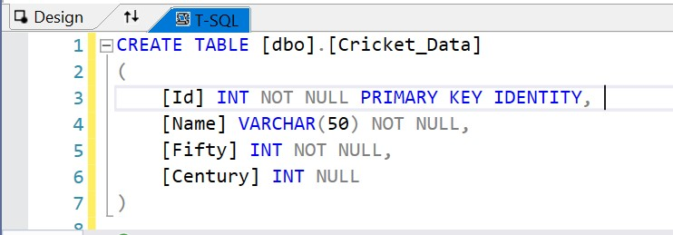Creating table in SQL Server.
* Query to convert csv to database table.

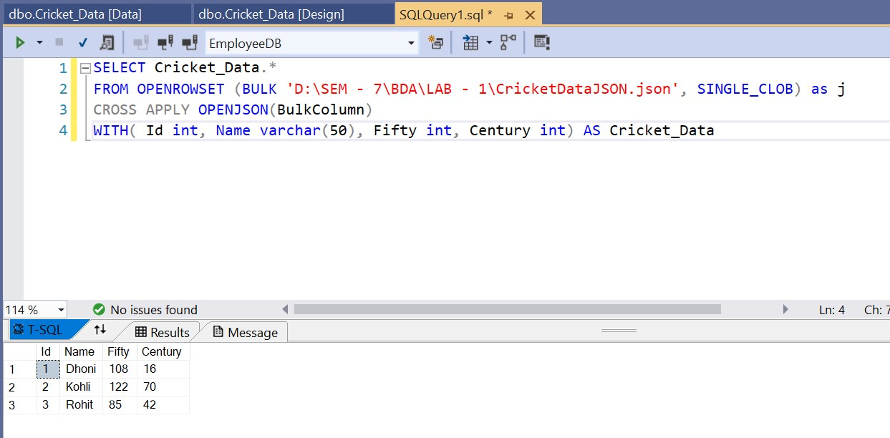

**Q. 5: Export database dump for data migration/archival.**

* We can easily export any SQL for of database using phpMyAdmin window of Xampp.

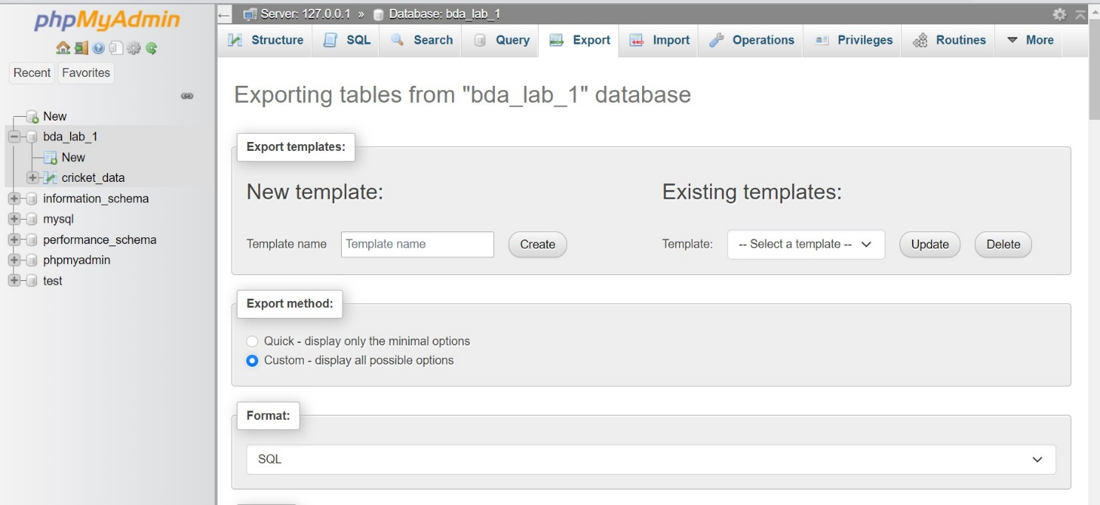

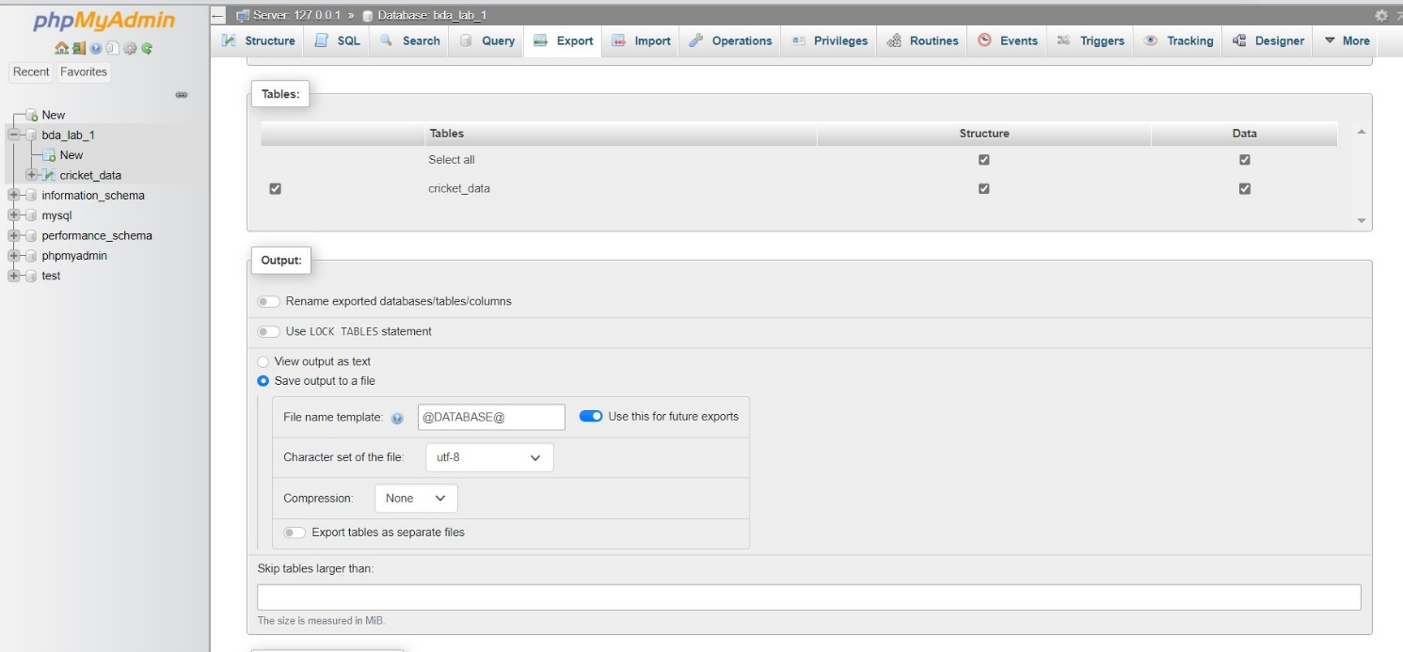

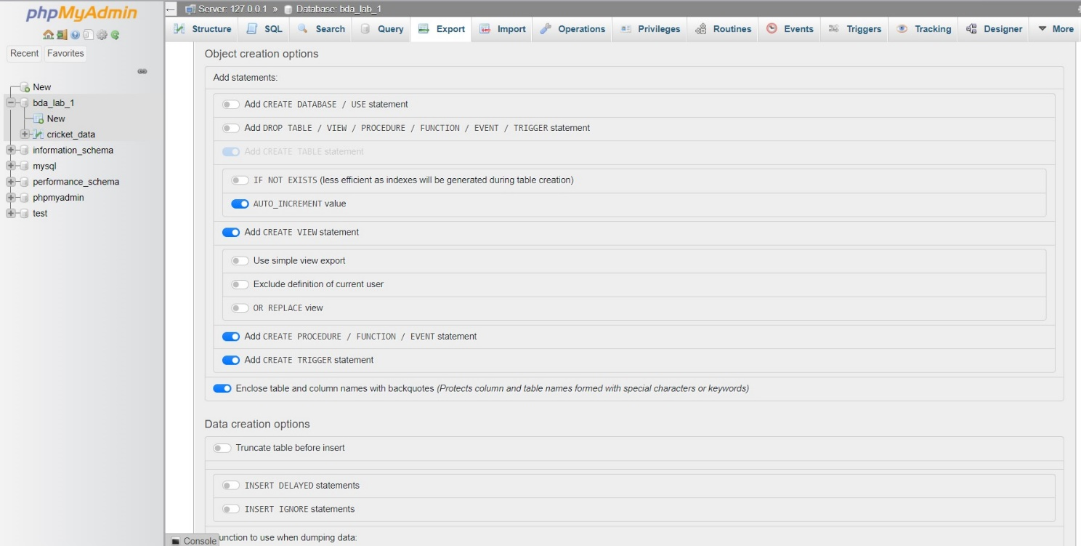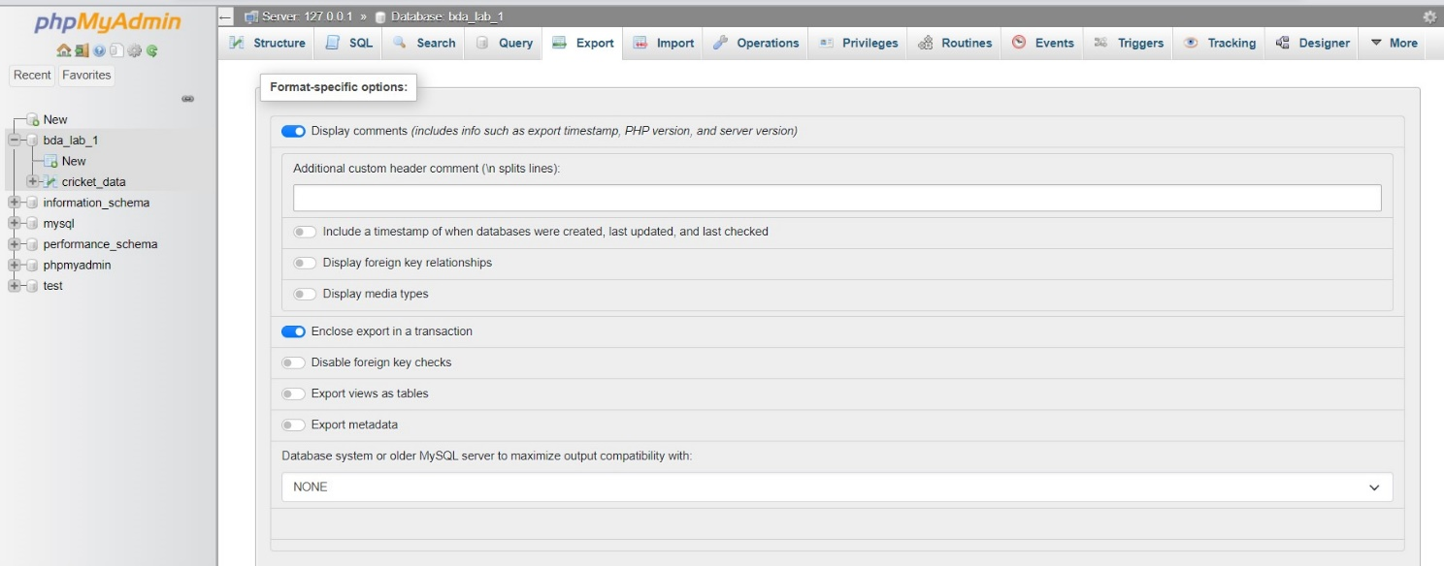

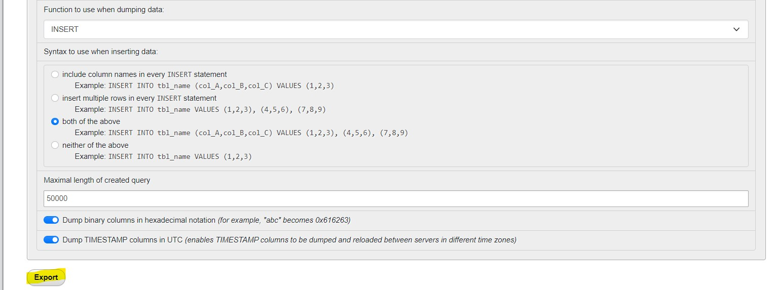

* 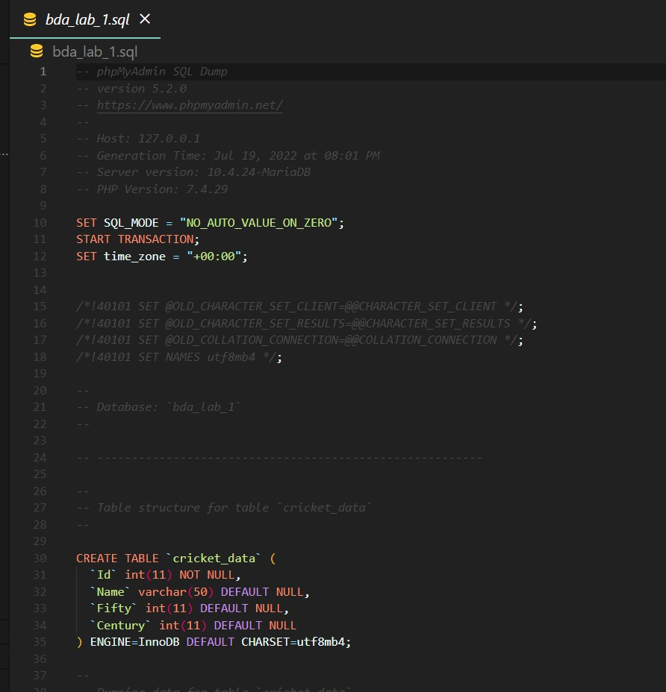**Output file:**

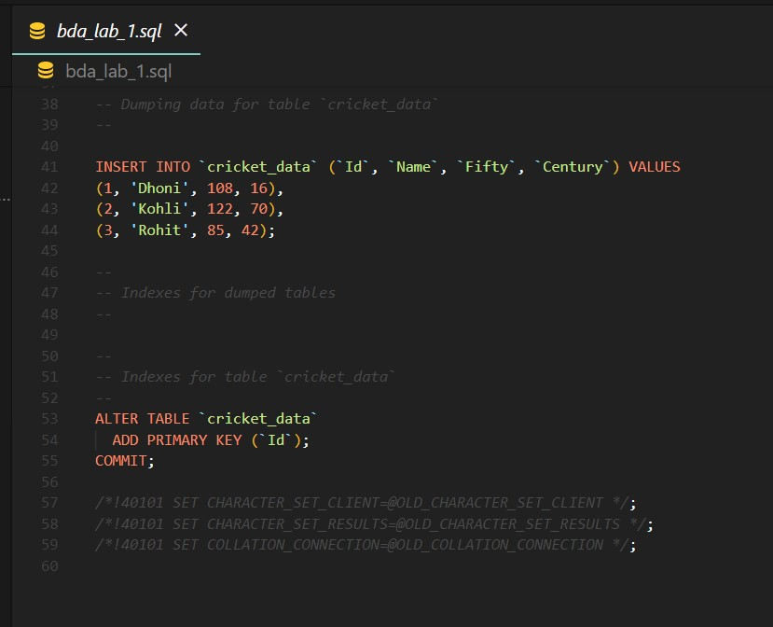

**Q. 6: Validate/Map data types across different database systems when migrating from one to another.**

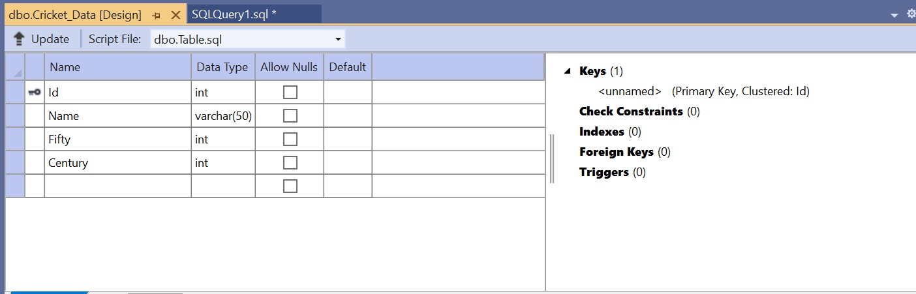

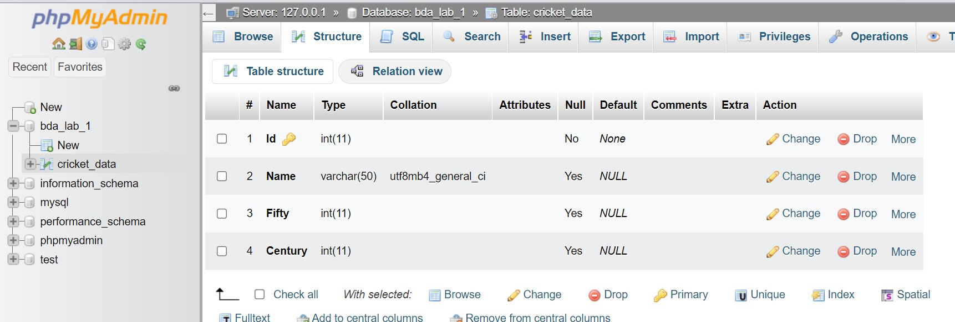

**Q. 7: Represent data cube and perform operations. OLTP – Data Warehouse.**

* 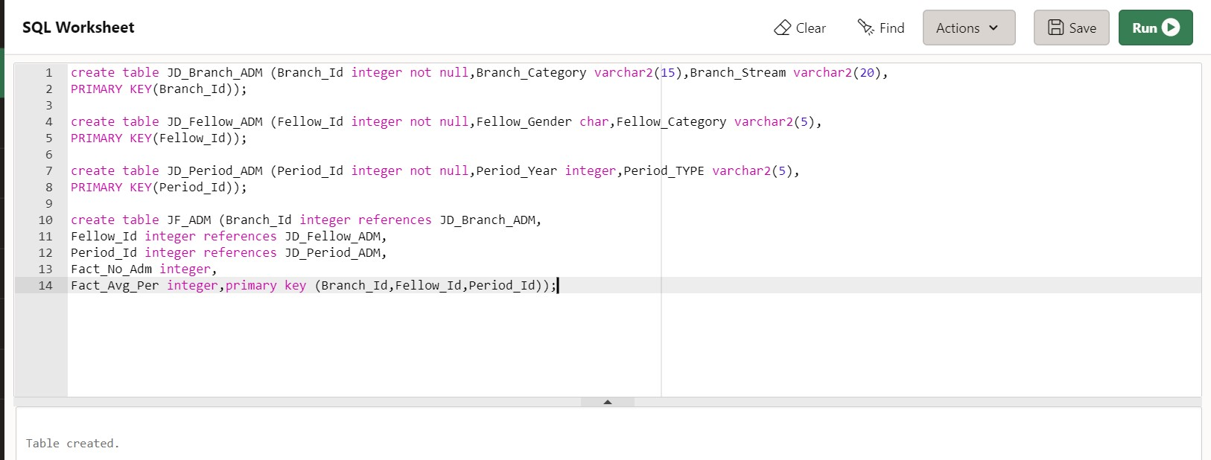**Creating tables:**
* 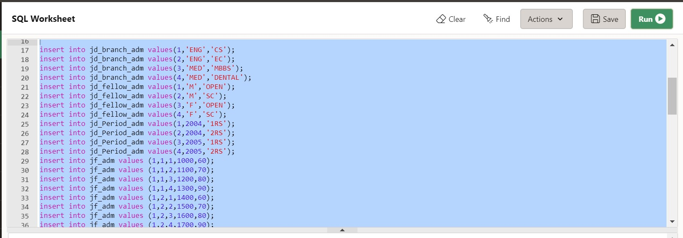**Inserting data into tables:**
* 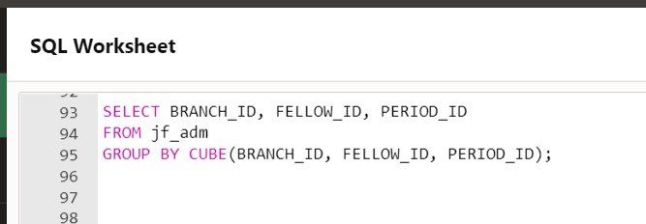**Representing data as data cube:**

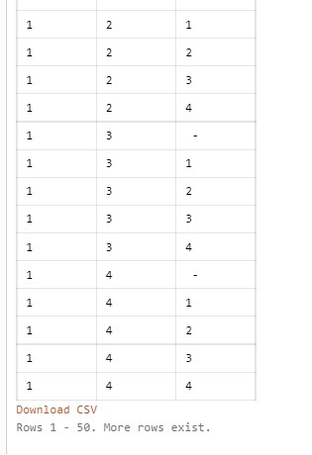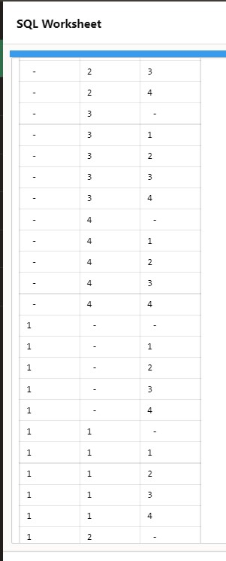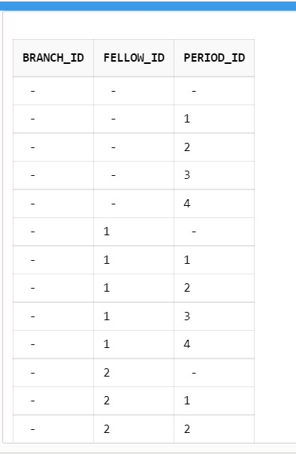

* 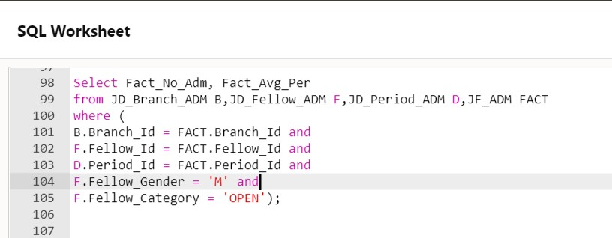**Slice operation:**

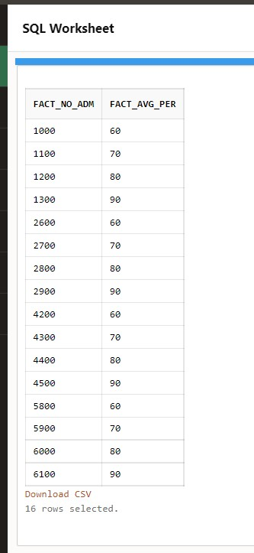

* 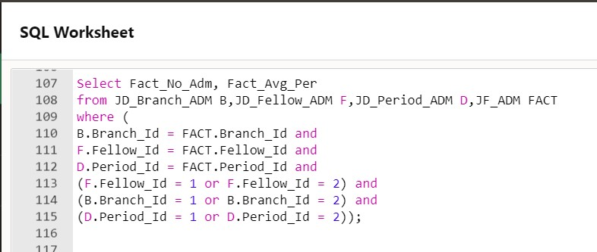**Dice operation:**

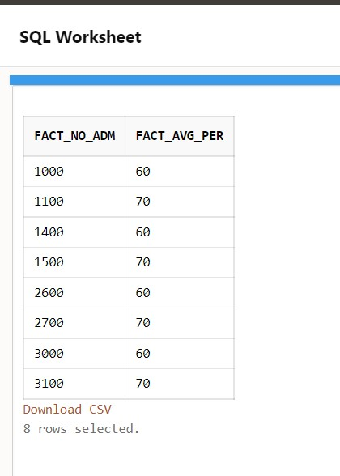

* **Roll up operation:**

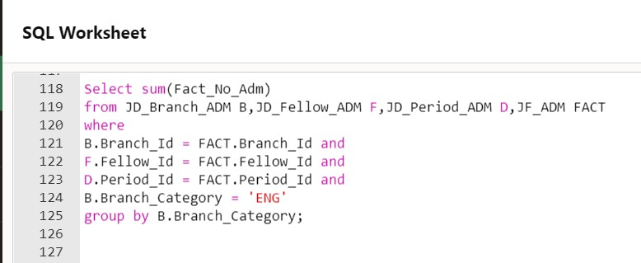

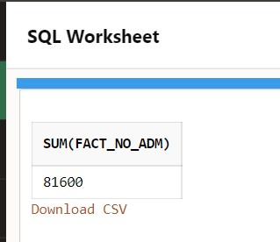

**Q. 8: Generate pdf report. / Use any virtualization tool.**

